EXE 1: Confidence Interval Estimation Using SPSS.
OBJECTIVE: The objective of this lab is to estimate the 95% confidence interval for the mean height of a given dataset using SPSS software.

QUESTION:
Find confidence interval of mean assuming normal distribution for following data.
Height:
78, 55, 68, 48, 65, 76, 57, 55, 65, 75, 51, 61, 68, 67, 76, 78, 71, 56, 57, 67, 58, 51, 50, 58, 50, 77, 55, 48, 70, 55, 58, 69, 76, 61, 68, 78, 56, 78, 57, 66, 66, 74, 62, 74, 76, 50, 69, 75, 65, 48, 70, 56, 52, 74, 61, 66, 48, 73, 71, 70

WORKING EXPRESSION:
The confidence interval for the mean is calculated using the formula:

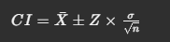
where: _
X = sample mean
Z = critical value for 95% confidence level (1.96 for a normal distribution)
6 = standard deviation
n = sample size

CALCULATION:

From SPSS output:
Case Processing Summary
 | Cases
 | Valid |  | Missing |  | Total
 | N | Percent | N | Percent | N | Percent
height | 60 | 100.0% | 0 | 0.0% | 60 | 100.0%

Descriptives
 |  |  | Statistic | Std. Error
height | Mean |  | 63.8833 | 1.23327
height | 95% Confidence Interval for Mean | Lower Bound | 61.4156
height | 95% Confidence Interval for Mean | Upper Bound | 66.3511
height | 5% Trimmed Mean |  | 63.9815
height | Median |  | 65.5000
height | Variance |  | 91.257
height | Std. Deviation |  | 9.55287
height | Minimum |  | 48.00
height | Maximum |  | 78.00
height | Range |  | 30.00
height | Interquartile Range |  | 16.50
height | Skewness |  | -.136 | .309
height | Kurtosis |  | -1.258 | .608
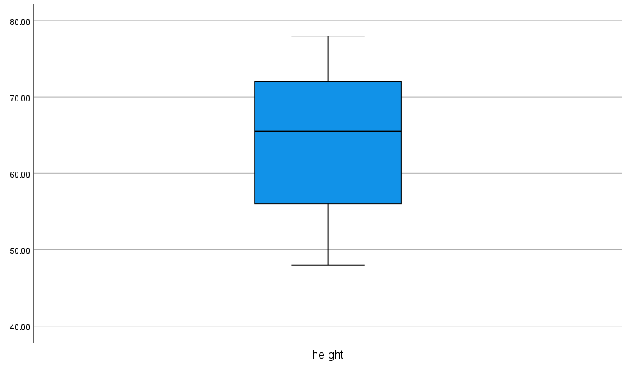
Figure: Boxplote of the given question.

RESULT:
The computed 95% confidence interval for the mean height is (61.42, 66.35).

CONCLUSION:
The results indicate that we can be 95% confident that the true mean height of the population falls within the interval (61.42, 66.35). The data appears to be normally distributed, making the confidence interval estimation valid.

